A Mobile Go-n-Grasp Application for School Canteens
USER MANUAL
Soukaina Nait Hmid 3035077753
Ofembe Eneufei Emmanuel 2009539315

CLIENT
1. Start mobile application or go to homepage of the client website.
2.Log in using UID and password.
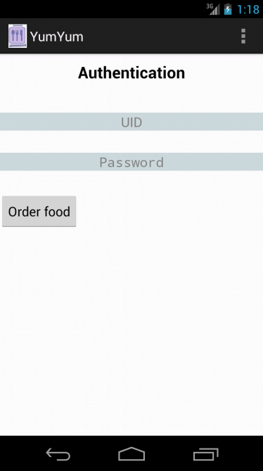
3.Select items to order.
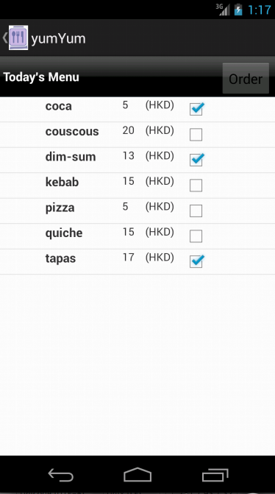
4.Confirm order.
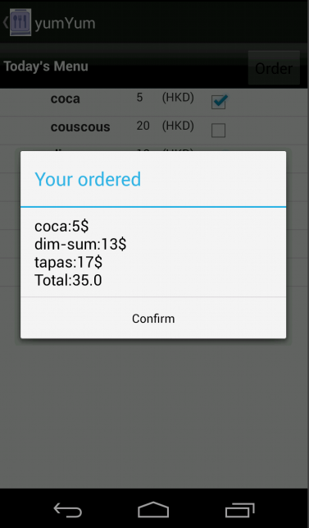
5.Log out
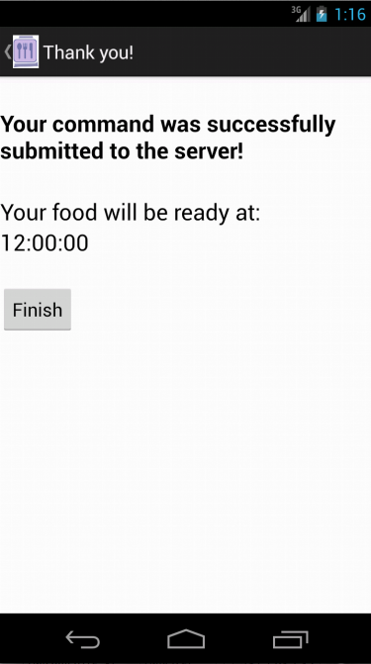

SERVER
1. Start server application on homepage of server website.
1.Log in to view menu database.
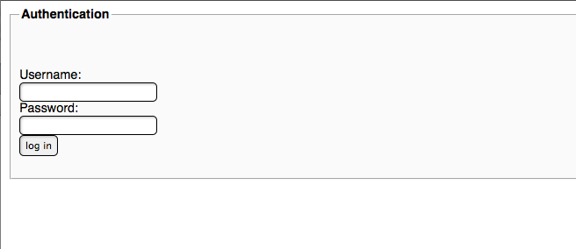
2.Add or modify items on menu.
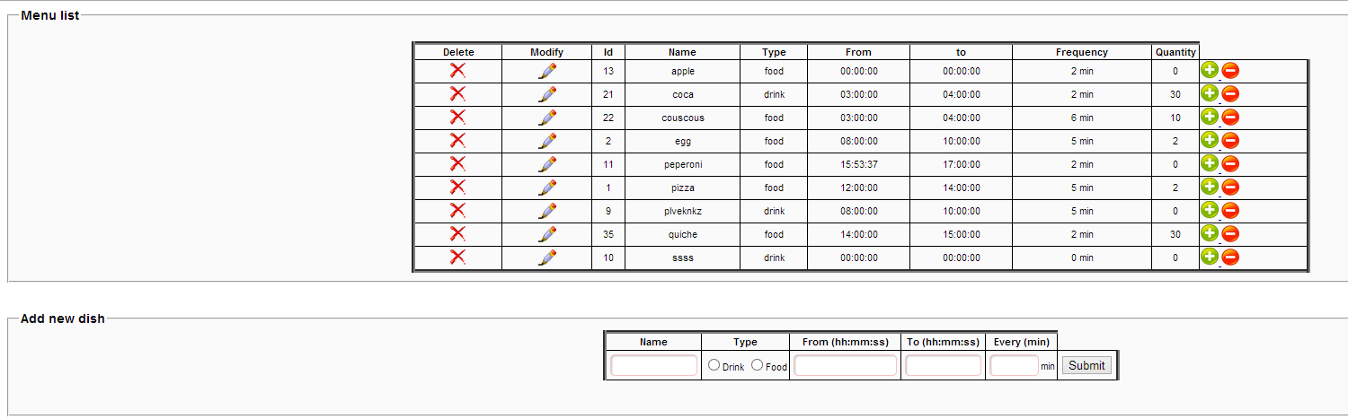
3.Log out

